**Conflicting grapheme-phoneme mappings lead to the production of hybrid L1/L2 sounds by immersed bilinguals**

Adults living in a country where their second language (L2) is spoken are surrounded by both aural and visual information in their L2. Interactions between the phonetic systems of a bilingual´s first language (L1) and L2 are well researched [1], but the influence of grapheme-phoneme mappings (GPMs) on speech production across languages is not well studied outside the language classroom, despite indications that inconsistencies in GPMs across languages impact L2 production for learners in immersion [2].

In this study, 21 native French speakers immersed in Spain for 4 to 29 years (mean=12 years) produced Spanish words containing /b/ in initial position. All participants had learned Spanish after the age of 12 and had moved to Spain as adults, where they used Spanish professionally. In Spanish, /b/ is associated with the graphemes <b> and <v>. These graphemes are associated with the sounds /b/ and /v/ in French, respectively. Nineteen control Spanish speakers with no knowledge of French were tested on the same tasks. Words were controlled across graphemes for number of syllables, following vowel, and frequency. They were produced during picture naming and reading tasks, to determine whether a potential effect of L2 orthography on production was dependent on the visual form of the word being activated by reading.

We expected that when Spanish /b/ is written as <v>, bilinguals would be influenced by the French fricative /v/ in production. Tokens were analyzed using the plosion index [3], an automatic measurement used to quantify the energy of a plosive burst in relation to the closure phase of the same plosive. Results are displayed in Fig.1. They show that bilinguals produced /b/ less energetically in the /b/-<v> condition than in the /b/-<b> condition. Spanish controls did not differ on their production of /b/-<v> and /b/-<b>. Bilinguals did not produce a bimodal distribution with clearly separated [b] and [v] productions in the /b/-<v> condition, but rather a range of realizations sharing features from both [b] and [v]. This effect was equally present in the picture naming and reading tasks, indicating that it is not dependent on the visual form of the word being activated by the environment.

These data demonstrate that GPMs across languages have an impact on the L2 production of even highly proficient immersed bilinguals, leading to the apparition of hybrid sound categories. Such categories had been reported before between fricatives [4] and vowels [5], but are shown here for the first time for sounds with different manners of articulation and for very proficient bilinguals. We also show for the first time that L2 learners can maintain two different phonetic categories for a single L2 sound, when this sound is written with different letters. These results point to the need for models of bilingual speech to account for the integration of both visual and auditory information in the formation, but also the development of L2 phonetic categories in the long term.

And what are the implications/take home message?

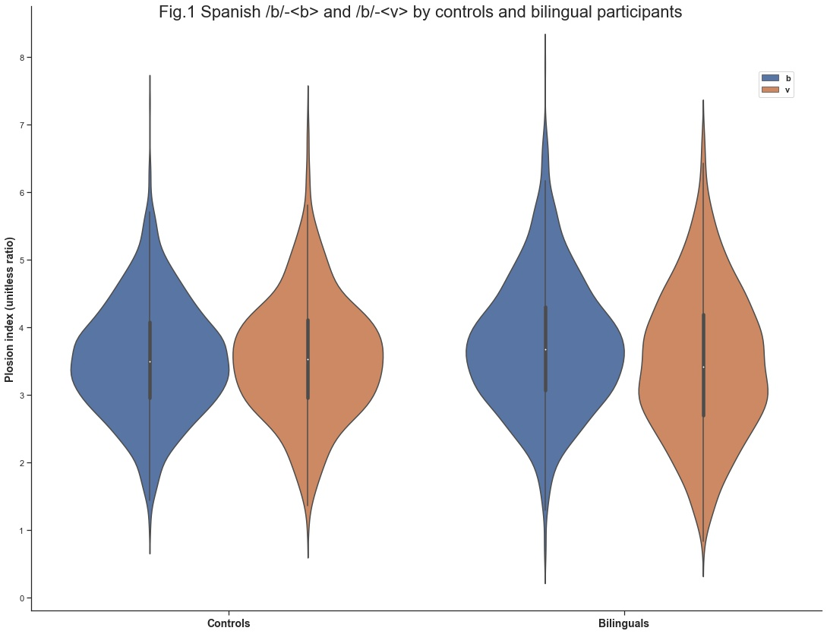

**References:**

[1] Flege, J. E. (1995). Second language speech learning: Theory, findings, and problems. *Speech perception and linguistic experience: Issues in cross-language research*, 92, 233-277.

[2] Young-Scholten, M., & Langer, M. (2015). The role of orthographic input in second language German: Evidence from naturalistic adult learners’ production. *Applied Psycholinguistics,* 36(1), 93-114.

[3] Ananthapadmanabha, T. V., Prathosh, A. P., & Ramakrishnan, A. G. (2014). Detection of the closure-burst transitions of stops and affricates in continuous speech using the plosion index. *The Journal of the Acoustical Society of America,* 135(1), 460-471.

[4] Rafat, Y., & Stevenson, R. A. (2019). Auditory-orthographic integration at the onset of L2 speech acquisition. *Language and speech*, 62(3), 427-451.

[5] Nimz, K., & Khattab, G. (2020). On the role of orthography in L2 vowel production: The case of Polish learners of German. *Second Language Research*, 36(4), 623-652.